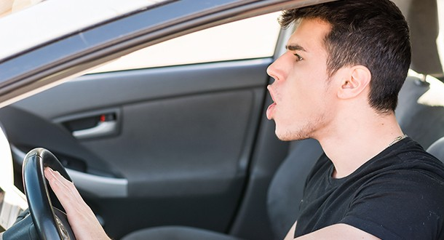

**Nearly 80 Percent of Drivers Express Significant Anger, Aggression or Road Rage**

Share

[**Save**](https://www.pinterest.com/pin/create/button/?guid=zEXLFma8m7pK-1&url=https%3A%2F%2Fnewsroom.aaa.com%2F2016%2F07%2Fnearly-80-percent-of-drivers-express-significant-anger-aggression-or-road-rage%2F&media=https%3A%2F%2Fnewsroom.aaa.com%2Fwp-content%2Fuploads%2F2016%2F07%2FAngry-Driver.jpg&description=Nearly%2080%20Percent%20of%20Drivers%20Express%20Significant%20Anger%2C%20Aggression%20or%20Road%20Rage%20%7C%20AAA%20NewsRoom)

[](mailto:trjohnson@national.aaa.com)*An Estimated Eight Million Drivers Admit to More Extreme Behavior Says New AAA Foundation Research*

WASHINGTON, D.C. (July 14, 2016)- Nearly 80 percent of drivers expressed significant anger, aggression or road rage behind the wheel at least once in the past year, according to a new study released today by the AAA Foundation for Traffic Safety. The most alarming findings suggest that approximately eight million U.S. drivers engaged in extreme examples of road rage, including purposefully ramming another vehicle or getting out of the car to confront another driver.

“Inconsiderate driving, bad traffic and the daily stresses of life can transform minor frustrations into dangerous road rage,” said Jurek Grabowski, Director of Research for the AAA Foundation for Traffic Safety. “Far too many drivers are losing themselves in the heat of the moment and lashing out in ways that could turn deadly.”

A significant number of U.S. drivers reported engaging in angry and aggressive behaviors over the past year, according to the study’s estimates:

* Purposefully tailgating: 51 percent (104 million drivers)
* Yelling at another driver: 47 percent (95 million drivers)
* Honking to show annoyance or anger: 45 percent (91 million drivers)
* Making angry gestures: 33 percent (67 million drivers)
* Trying to block another vehicle from changing lanes: 24 percent (49 million drivers)
* Cutting off another vehicle on purpose: 12 percent (24 million drivers)
* Getting out of the vehicle to confront another driver: 4 percent (7.6 million drivers)
* Bumping or ramming another vehicle on purpose: 3 percent (5.7 million drivers)

Nearly 2 in 3 drivers believe that aggressive driving is a bigger problem today than three years ago, while nine out of ten believe aggressive drivers are a serious threat to their personal safety.

Aggressive driving and road rage varied considerably among drivers:

* Male and younger drivers ages 19-39 were significantly more likely to engage in aggressive behaviors. For example, male drivers were more than three times as likely as female drivers to have gotten out of a vehicle to confront another driver or rammed another vehicle on purpose.
* Drivers living in the Northeast were significantly more likely to yell, honk or gesture angrily than people living in other parts of the country. For example, drivers in the Northeast were nearly 30 percent more likely to have made an angry gesture than drivers in other parts of the country.
* Drivers who reported other unsafe behaviors behind the wheel, such as speeding and running red lights, also were more likely to show aggression. For example, drivers who reported speeding on a freeway in the past month were four times more likely to have cut off another vehicle on purpose.

“It’s completely normal for drivers to experience anger behind the wheel, but we must not let our emotions lead to destructive choices,” said Jake Nelson, AAA’s Director of Traffic Safety Advocacy and Research. “Don’t risk escalating a frustrating situation because you never know what the other driver might do. Maintain a cool head, and focus on reaching your destination safely.”